  1 | Requirements Document
 | Revision A

Infoblox NIOS Software

Networking

PRD

–

REVISION | DATE | AUTHOR | REVISIONS
A | 11-Jun-06 | Tim Sylvester | Draft of Networking Requirements for NIOS.

Table of Contents
Introduction 4
1.1 Scope 4
1.2 Target Release Date 4
1.3 Stakeholders 4
1.4 Feature Nomenclature 4
2 Prioritized List of Requireme1nts 5
3 Networking and HA Enhancements 6
3.1 Define static routes on MGMT interface 6
3.1.1 Background and Customers 6
3.1.2 Use Case – Large OOB network 6
3.1.3 Requirements 6
3.2 Assign multiple IP addresses on an interface 7
3.2.1 Background and Customers 7
3.2.2 Use Case - Consolidating Two Existing DNS Servers to One IB Appliance 7
3.2.3 Requirements 8
3.3 Enable/disable ANY service on ANY interface 9
3.3.1 Background and Customers 9
3.3.2 Use Case – Running DNS and NTP on MGMT Interface 9
3.3.3 Requirements 9
3.4 Services on second LAN interface (Absolut hardware) 11
3.4.1 Background and Customers 11
3.4.2 Use Case – Data Center 11
3.4.3 Requirements 11
3.5 Anycast DNS 12
3.5.1 Background and Customers 12
3.5.2 Use Cases – Redundant DNS Service 13
3.5.3 Requirements 13
3.6 Services on internal loopback interface 15
3.6.1 Background and Customers 15
3.6.2 Use Case – Reliable DNS service in Dual Home Environment 15
3.6.3 Requirements 15
3.7 VIP on MGMT & LAN2 interfaces 16
3.7.1 Background and Customers 16
3.7.2 Use Cases – Providing DNS service on an OOB network 16
3.7.3 Requirements 16
3.8 Internal firewall 17
3.8.1 Background and Customers 17
3.8.2 Use Case - Dropping Packets from a DOS Attack 17
3.8.3 Requirements 17
3.9 VLAN tagging (802.1q) 19
3.9.1 Background and Customers 19
3.9.2 Use Cases 19
3.9.3 Requirements 19
3.10 Dual homing 20
3.10.1 Background and Customers 20
3.10.2 Use Cases 20
3.10.3 Requirements 20
3.11 Rate Limiting 21
3.11.1 Background and Customers 21
3.11.2 Use Cases 21
3.11.3 Requirements 21

Introduction

Scope
This document covers the Networking for NIOS.

Target Release Date
TBD

Stakeholders
Product Management, Engineering, QA, Support, Sales.

Feature Nomenclature
Below is a summary of the features in this release with their priority. A new feature numbering scheme has been developed for this PRD.

Feature Number Format: AAAA-NNN-XX
AAAA Component Code - This is an alphanumeric designation for the component of the product. For example, DHCP (DHCP Server), DNS (DNS Server), PLAT (Platform/NIOS), HW (Hardware), etc.

NNN Feature Number - This is a three digit number for the specific feature.

YY Requirement Number – This is a two digit number with the specific requirement of the feature.
Example: DHCP-001-01 is a specific requirement of the Authenticated DHCP feature:

Requirement Number | Description | Priority | Target Release
DHCP-001-01 | When an unauthorized/unregistered (i.e. its MAC address is not in the list of authorized MAC addresses) client connects to the network, it must be assigned a temporary IP address with a very short, administrator configurable, lease time. The default lease time should be 60 seconds.

Prioritized List of Requireme1nts
Rank | Feature Title |  | Status
1 | Define static routes on MGMT interface
2 | Assign multiple IP addresses on an interface
3 | Enable/disable ANY service on ANY interface
4 | Services on second LAN interface (absolute hardware)
5 | Anycast DNS
6 | Services on internal loopback interface
7 | VIP on MGMT LAN2 interfaces
8 | Internal firewall
9 | VLAN tagging (802.1q)
10 | Dual homing
11 | Rate limiting

Networking and HA Enhancements

Define static routes on MGMT interface

Background and Customers

Today a static route can be defined for the LAN interface on the appliance but no the management (MGMT) interface. The routing table in NIOS is interface specific. Most administrators are used to network devices that have multiple interfaces and a single routing table for the device. The static routing table functionality must be extended to all interfaces in the appliance including MGMT, LAN1, LAN2, HA and internal loopback interfaces.

Use Case – Large OOB network
Many customers that are using the MGMT interface have built an out-of-band (OOB) management network that connects all of the network infrastructure devices and servers. The OOB network is designed to isolate the management traffic from the product network for security reasons. In large networks, for example DISA and Telefonica, the OBB networks spans multiple sites and multiple networks. Adding a simple default route to the appliance will not allow the appliance to find all of the networks on the OBB network beyond the local LAN that the MGMT interface is connected. In order to meet the needs of these large networks, a routing table for all of the interfaces must be available.

Requirements
Requirement Number | Description | Priority | Target Release
Required Features
 | Administrators must be able to define static routes in the appliance that work for all interfaces in the appliance.
 | The appliance must NOT route packets between the interfaces. The only exception is routing packets between a physical network and the internal loopback network which is providing services on an internal loopback address.

Assign multiple IP addresses on an interface

Background and Customers
Customers want the ability to assign multiple IP addresses on an interface for migration purposes. When customers consolidate DNS servers or change network addressing, some clients my still point to the IP address of the old DNS server. Customers want to be able to assign the IP address of the old DNS server to the Infoblox appliance.
Customers Requesting these Features
- Time-Warner, NSC, Oxford, numerous others

Use Case - Consolidating Two Existing DNS Servers to One IB Appliance

This is an example of assigning multiple IP addresses to an interface.

The customer has two existing DNS servers (ns1.example.com – 192.204.18.11 and ns2.example.com – 192.204.18.12) in their network that they want to replace with one IB appliance which has a new IP address (ib1.example.com – 192.204.18.21).

The customer will be upgrading their 2000 DHCP clients to use the new IB appliance and they will be manually reconfiguring 25 servers that were statically configured to point at the old name servers. The migration process will take a couple of weeks. In the interim DNS service must be available on all three IP addresses – 192.204.18.11, 192.204.18.12 and 192.204.18.21.

The administrator deploys the IB appliance and assigns IP address 192.204.18.21 to the LAN interface.

The administrator shuts down ns1 and ns2.

The administrator assigns secondary IP addresses (192.204.18.11 & 192.204.18.12) to the LAN interface on the IB appliance.

Clients can query any of the IP addresses and their responses have a source IP address matching the query IP address.

All DNS functionality continues to work on the IB appliance including: DDNS, zone transfers, ACLs, and views.

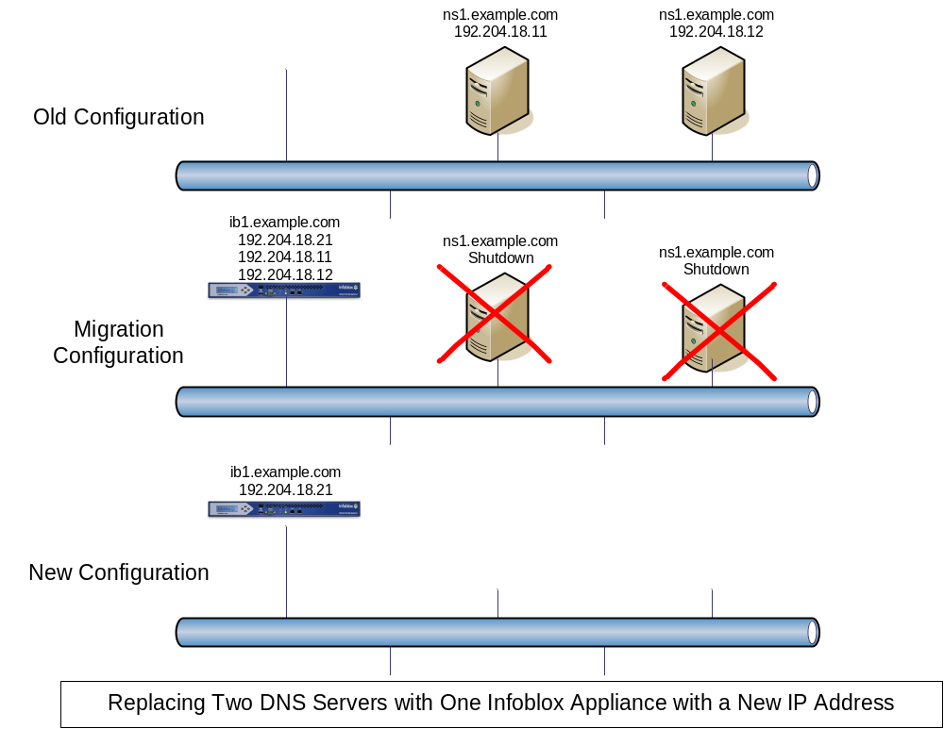

Requirements
Requirement Number | Description | Priority | Target Release
Required Features
NHAS-005-01 | Administrators must be able to define up to 10 sub-interfaces to the Ethernet interfaces on the IB Appliances that are serving protocols (LAN and HA). Administrators must be able to configure an IP address on the sub-interface and a default router for the interface.

Enable/disable ANY service on ANY interface

Background and Customers
.

Use Case – Running DNS and NTP on MGMT Interface

This is an example of running services on multiple interfaces.

The customer is deploying an Out-of-Band (OOB) management network that is connected to the management ports of all of their network infrastructure devices – switches, routers, appliances and servers. The OOB network will need DNS and NTP service but the OOB network is not connected to the production network.

The customer deploys the appliances in their network and uses the MGMT interface to connect to the OOB network for ID Grid communications and other management tasks.

DNS and NTP services are enabled for the MGMT interface to provide these services to the OOB network.

Traffic MUST NOT be forwarded (routed) between the production network and the OOB network via the IB appliance.

Requirements
Requirement Number | Description | Priority | Target Release
Required Features
Administrators must be able to configure all services to listen on any interface (physical or logical). The following services must be able to run on any interface:
- DNS Server
- DHCP Server
- GRID Communications
- SSH Server
- TFTP Server
- NTP Server
- Syslog Server
- RADIUS Proxy
- ICMP
- GUI
- SNMP
Administrators must be able to enable/disable client applications on the appliance from initiating a connection through a particular interface. Example client applications are:
- Recursive DNS
- SNMP Traps
- Syslog Messages
- Backups using TFTP & FTP
- DIG
- PING/TRACEROUTE

Services on second LAN interface (Absolut hardware)

Background and Customers
The new Absolut hardware platforms shipping from Infoblox include a fourth physical network interface called LAN2. The implication is that services will run on this interface and allow the appliance to reside on multiple networks. As customer purchase the new appliances, they will become frustrated with this missing functionality. In addition, enabling the LAN2 interface will allow customers to deploy the appliance in new configurations.

Use Case – Data Center

Requirements
Requirement Number | Description | Priority | Target Release
Required Features
 | The LAN2 interface must be able to provide services.
 | The LAN1 and LAN2 interfaces must be able to reside on the same subnet or different subnets.
 | The LAN2 interface must be able to share a VIP with the LAN2 interface of another appliance in an HA pair.

Anycast DNS

Background and Customers
Anycast is an IP addressing technique where unicast IP addresses are assigned to multiple hosts and routes configured accordingly. Routers receiving packets destined for anycast addresses select on of potentially several valid paths to hosts configured with the address.
By utilizing anycast addressing, we could improve the reliabitlity of DNS service, load balance DNS requests across a number of members in a grid, minimize service downtime due to maintenance and automatically direct requests to the topologically nearest member. It enables the assignment of one IP anycast address to multiple grid members.

Other problem faced by DNS administrators is the difficulty of moving DNS servers. By definition, recursive DNS servers must be configured by IP address, when the DNS server IP address changes each client must update its server address list. Using of DHCP helps minimize the difficulty of changing these addresses, but there’re inevitably cases where DN Server info. is statically configured. The use of anycast DNS virtually eliminates the hassle of changing server addresses. As new grid members are added and old ones removed, traffic is automatically redirected by routers and clients are unaware of the particular grid members answering their DNS requests. In addition, an enterprise with multiple locations could use the same anycast addresses in all locations, further reducing the complexity of DNS configuration.

Using anycast addressing techniques and host-based routing daemons, we could dramatically increase the reliability of recursive DNS service. This reliability is achieved by eliminating the dependence upon a single machine to answer requests to a specific IP address. Specifically, multiple grid members that provide identical DNS services are each configured with the anycast IP address on an interface. When using these techniques, a single unreachable host is of little consequence as routers redirect all requests to working members

RFC1546 – Host Anycasting Service by Partridge, C, T. Mendez, and W. Milliken
URL: http://www.ietf.org/rfc/rfc1546.txt?number=1546

Customers Requesting these Features
- HP, Georgia Tech, E*Trade, Credit Swiss, NATO and Disney in Orlando

Use Cases – Redundant DNS Service

A range of addresses (within IP space in our control) identified for anycast-enabled services: 128.2.1.0/26. Two addresses within this range for anycast recursive DNS service: 128.2.1.10 and 128.2.1.11 are identified. Each site deploying anycast services should take care to designate addresses within IP blocks in their control. The unique addresses of the DNS servers are listed beneath the anycast address in the figure.

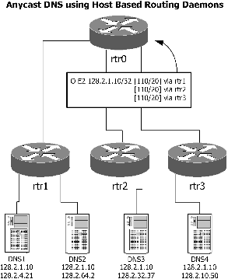

Requirements
Requirement Number | Description | Priority | Target Release
Required Features
 | Able to designate of certain unicast IP addresses as anycast addresses IP address to be the same for those grid members would like to participate anycast pool. A small subnet as anycast addresses could be used. While this subnet is not attached to any router interface, individual addresses within the subnet are used to provide a particular service. | 1 | 4.1
 | A member of the anycast service pool must have the designated anycast address configured on a local interface. Typically, a new virtual loopback interface is added and the anycast address is assigned to this interface. | 1 | 4.1
 | The DNS software must be able to recognize and listen to network requests on the anycast address. In environments where anycast is the only valid method of querying the DNS grid members, administrators can specifically reject requests on the non-anycast addresses. | 1 | 4.1
 | Running a host-based routing daemon ( XORP routing daemon and others are available as host router due to its open source license and support for OSPF) on each grid member to make the entire grid more robust and reliable. In this case, each member announces a route to its anycast address using the intro-domain routing protocol. This route is then propagated through the routing domain, subject to the constraints of the IGP - OSPF. Routers within the domain will select the best path to a member announcing the anycast address | 1 | 4.1

Services on internal loopback interface

Background and Customers
On a network device with multiple network interfaces, it is common to assign an IP address and run services on an internal interface. A router is advertised the internal IP address through the other interfaces on the device.

Use Case – Reliable DNS service in Dual Home Environment

An administrator is deploying a new IB-1550 which has two LAN interfaces – LAN 1 and LAN 2.

The administrator is deploying the appliance in a data center that has deployed redundant layer 2/3 switches for the servers. All servers in the data center are dual homed to two switches. Each switch has is on a different subnet (SWITCH-A - 192.204.18.0/24 and SWITCH-B 192.204.19.0/24). Dual homing provides an added layer of redundancy for the services offered on the servers in the data center.

The administrator installs the appliances and connects LAN 1 to a port on SWITCH-A and LAN 2 to a port on SWITCH-B. LAN-1 is assigned IP address 192.204.18.31. LAN-2 is assigned IP address 192.204.19.31. The Loop Back (internal) interface is assigned address 192.204.20.31 on subnet – 192.204.20.0/24. The layer 2/3 switches are configured to advertise a route to the host 192.204.20.31 via addresses 192.204.18.31 and 192.204.19.31.

If either of the switches goes down, DNS service would still be available through the other switch using the same IP address for the DNS server – 192.204.20.31. This configuration would also work if stand-alone layer 2 switches and routers were used in place of the combined layer 2/3 switch.

Requirements
Requirement Number | Description | Priority | Target Release
Required Features
 | Administrators must be able to configure up to 10 internal loopback interfaces on the appliance.
 | Any service must be able to run on the internal loopback interface.
 | Traffic from LAN1 and LAN2 interfaces must be able to be forwarded (routed) to the internal loopback interface.

VIP on MGMT & LAN2 interfaces

Background and Customers

Use Cases – Providing DNS service on an OOB network
DISA would like to provide DNS service to devices on its OOB network using an Infoblox appliance. At the same, they want to provide DNS service on the production network using the LAN1 and LAN2 interfaces. The appliances are in an HA pair DISA would like the services running on any pair of interfaces to be redundant. So, the MGMT & LAN2 interfaces must be able to support a VIP.

Requirements
Requirement Number | Description | Priority | Target Release
Required Features
 | The MGMT and LAN2 interfaces must be able to share a VIP with its companion interface on the other appliance in an HA pair.

Internal firewall

Background and Customers
One of the benefits of the appliance model is increased security of the device. Our customers are extremely security conscious and want to control what services run on which port. This can be accomplished using an internal firewall. The most common internal firewalls for Linux are based on Net Filter at: http://www.netfilter.org.
Customers Requesting these Features
Visa

Use Case - Dropping Packets from a DOS Attack

Since DNS and DHCP are critical network services, it is a candidate for a denial of service attack. It is important that DNS be secure and reliable.

To help protect the DNS and DHCP from DOS attacks, either malious or unintended, a firewall can be used to drop packets that are not destine for the appliance.

An administrator configures the appliance to provide DNS and DHCP services. The firewall rules on the appliance are automatically updated to allow packets destine for those services to be processed by the IP stack. Packets not destine for one of those services are immediately dropped without sending a response to the sender and logged in syslog.

The administrator can configure access rules for the firewall that only allow packets from certain IP addresses to be sent to the server. For example, only clients from the network 192.204.44.0/22 can query the DNS server

The benefit of applying the rules at the firewall level are that there are consistently configured across protocols and configured in one place of the ID Grid Manager.

Requirements
Requirement Number | Description | Priority | Target Release
Required Features
NHAS-006-01 | Administrators must be able to enable and disable in-bound services in the GUI by Ethernet interface (LAN1, LAN2, HA and MGMT). The in-bound services that need to be controlled are ICMP, SSH, GUI, SSL VPN, and SNMP. | 1 | 4.1
NHAS-006-02 | Administrators must be able to enable and disable out-bound functions in the GUI by Ethernet interface (LAN, HA, MGMT). The out-bound functions that need to be controlled are SSL VPN, SNMP, SYSLOG and SMTP. | 1 | 4.1

VLAN tagging (802.1q)

Background and Customers

Use Cases

Requirements
Requirement Number | Description | Priority | Target Release
Required Features
PLAT-013-01 | Administrators must be able to configure 802.1q VLAN tags on an interface. | 1 | -

Dual homing

Background and Customers

Use Cases

Requirements
Requirement Number | Description | Priority | Target Release
Required Features

Rate Limiting

Background and Customers

Use Cases

Requirements
Requirement Number | Description | Priority | Target Release
Required Features

